Graph. Normal  - Roads Count  - Find a ring road  - Is there another country? | Graph. Advanced  - Find a ring road  - Path from near side to far side  - Is there another country?

Graph. Normal
In Milky Way galaxy there is a planet Neptune with N cities. Some of them are connected with roads.
Adjacency matrix - matrix N*N, for each pair of cities you have 1 or 0: if i-th city is connected with k-th city by road - 1, otherwise - 0.
Adjacency list - you have a list with pairs of connected roads
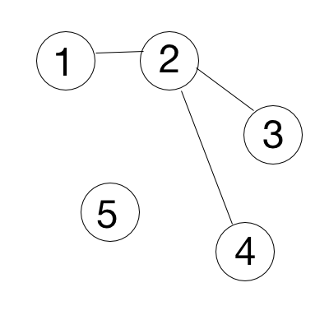
- Roads Count. You need to print out a count of roads by given adjacency matrix. Input: 1st row - N, number of cities, next N rows - adjacency matrix.
Input: Output:
5 3
0 1 0 0 0
1 0 1 1 0
0 1 0 0 0
0 1 0 0 0
0 0 0 0 0

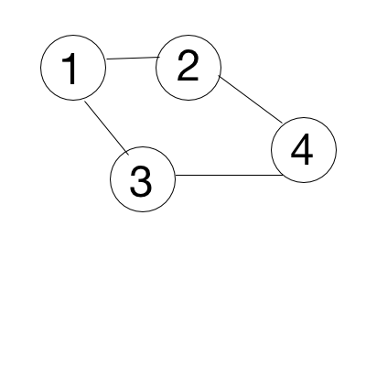
- Find a ring road. You need to print “Ring road” if there are roads that make a ring road, “Tree structure” - otherwise. Input: 1st row - N, number of cities, next N rows - adjacency matrix.
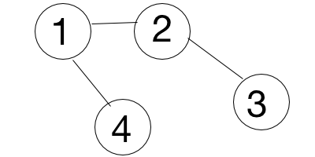
Input: Output: Input: Output:
4 Ring road 4 Tree structure
1 1 1 0 1 1 0 1
1 1 0 1 1 1 1 0
1 0 1 1 0 1 1 0
0 1 1 1 1 0 0 1

- Is there another country? If two cities are connected, they belong to the same country. You need to check if there is only one country on a planet. Print YES - if only one, NO - otherwise. Input: 1st row - N, K, where N - number of cities, K - number of roads, next K rows - adjacency list.
Input: Output: Input: Output: Input: Output:
5 4 YES 1 0 YES 5 2 NO
1 2 1 2
3 4 4 5
5 2
4 5

Graph. Normal  - Roads Count  - Find a ring road  - Is there another country? | Graph. Advanced  - Find a ring road  - Path from near side to far side  - Is there another country?

Graph. Advanced

- Find a ring road. Some of those roads are one way roads. You need to print “Ring road” if there are roads that make a ring road, “Tree structure” - otherwise. Input: 1st row - N, number of cities, next N rows - adjacency matrix.

1
2
3
4
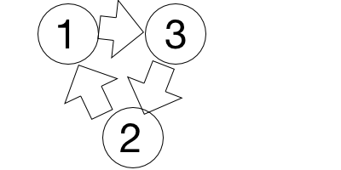 | Input:  3  1 0 1  1 1 0  0 1 1 | Output:  Ring road | Input:  4  1 0 1 1  0 1 0 0  0 0 1 0  0 0 0 1 | Output:  Tree structure

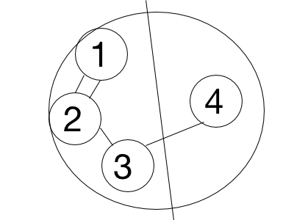
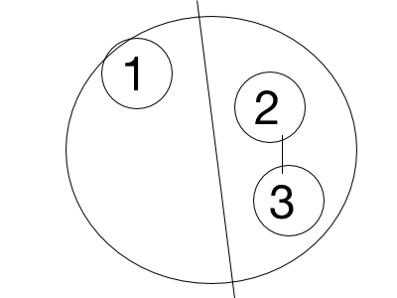
- Path from near side to far side. Some cities are on the near side of Neptune, others are on the far side. Print ”YES” if there is a path from the near side to the far side, otherwise - “NO”. Input: 1st row - N, M, K, where N - total number of cities, M - number of roads, K - number of cities on the near side, 2nd row - the list of K cities on the near side, next M rows - adjacency list of roads.
Input: Output: Input: Output:
5 4 3 <- 5 cities, 4 roads. 3 cities near side YES 3 1 1 NO
1 2 3 <- the 3 cities on near side 1
1 2 2 3
2 1
2 3
3 4

- Is there another country? If two cities are connected, they belong to the same country. You need to print all cities for each country. Input: 1st row - N, K, where N - number of cities, K - number of roads, next K rows - adjacency list.
Input: Output: Input: Output: Input: Output:
5 3 1 2 5 1 0 1 5 2 1 2
1 2 3 4 1 2 3
3 4 4 5 4 5
5 2

